**Listing.io: Inventory Management System**

Made by Reymar Dela Paz

Table of Contents

Objectives 3

Who are the users? 4

Tech Stack 5

Tools and Software 6

Website Walkthrough 7

HOME PAGE 7

ADD PRODUCTS 8

VIEW PRODUCTS 9

EDIT BUTTON 10

DELETE BUTTON 11

Developer’s Notes 12

# Objectives

The main objective of this project is to have an overall useful inventory management system that enables the user to add, maintain, delete and view inventory products.

# Who are the users?

1. User – the main user is welcomed by the home screen in which he or she can choose to add a product or to view the list of products.

# Tech Stack

**BACK-END: JAVA Spring MVC, MYSQL Database, JDBC**

**FRONT-END: HTML, JSP, CSS**

# Tools and Software

1. MYSQL database
2. IDE – Personally, the developer used Eclipse for the development of this project. This is done with Apache Tomcat Server

# Website Walkthrough

## HOME PAGE

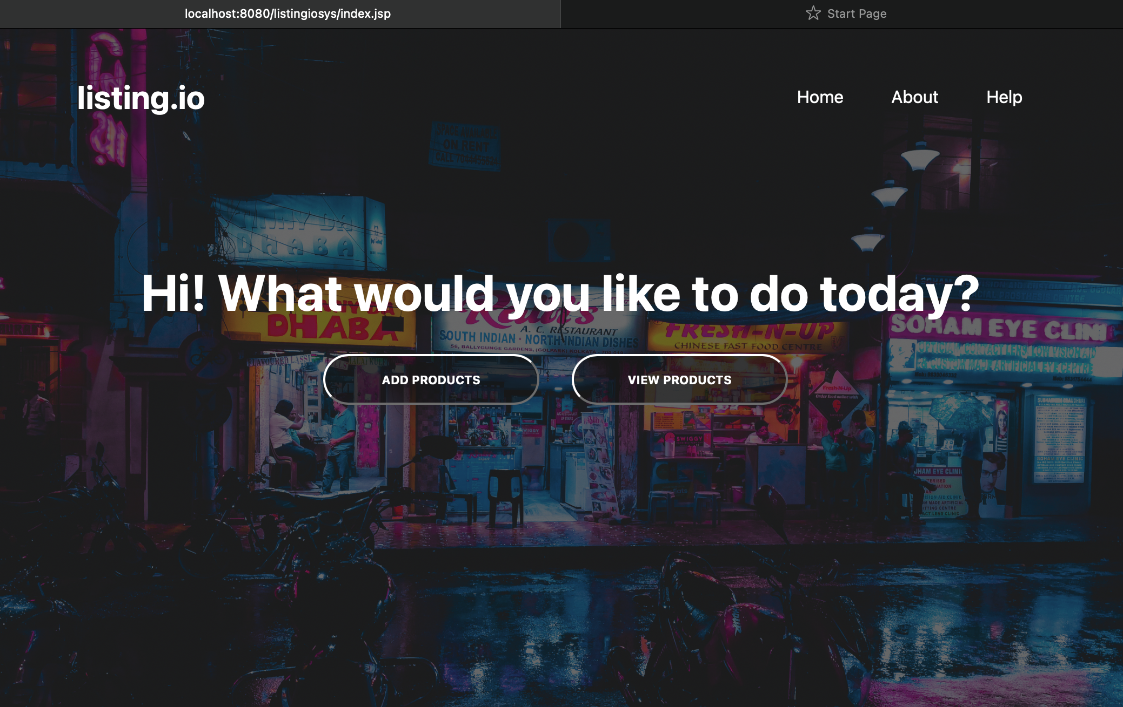

The homepage has a navigation menu at the top where it contains the name of the project, as well as Home, About and Help options. There are also two options, Add Products and View Products.

## ADD PRODUCTS

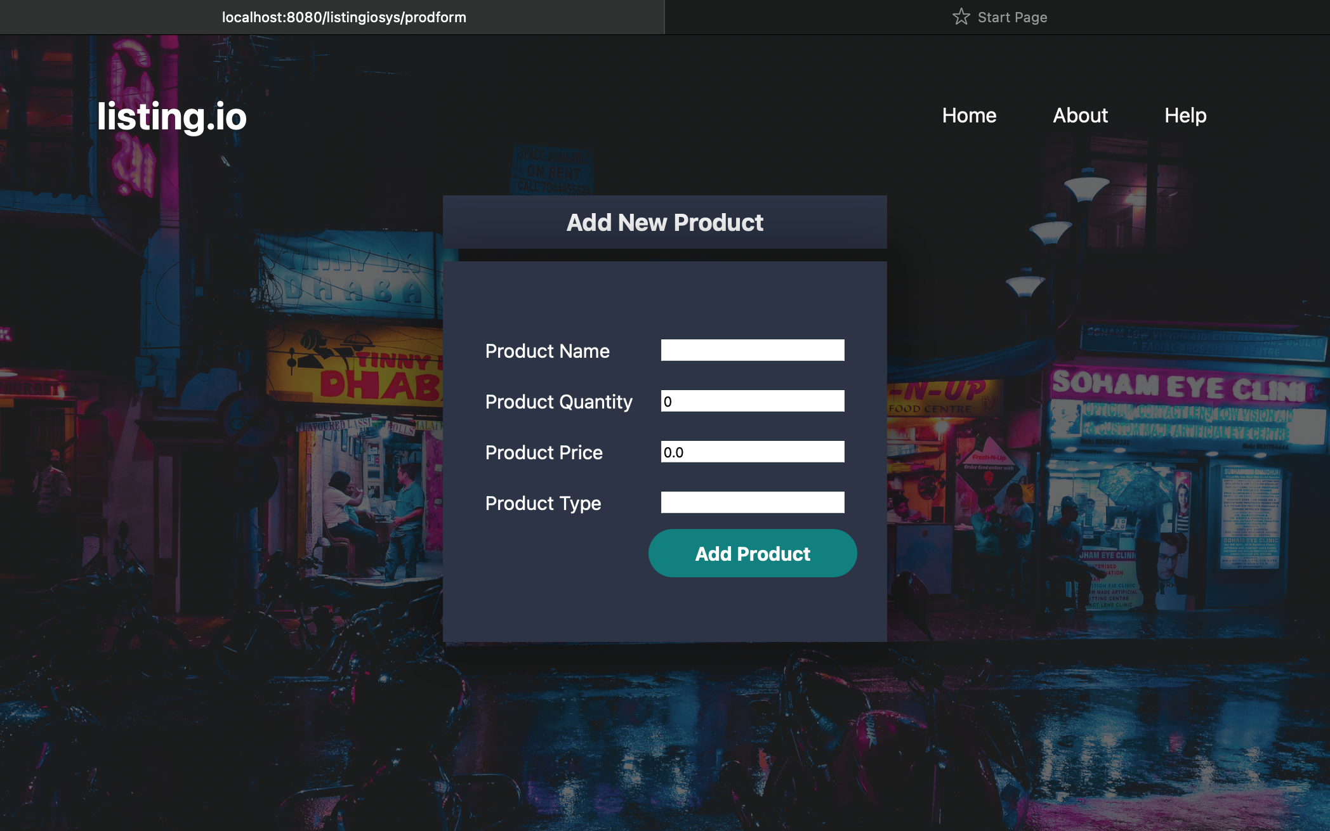

The Add a Product button directs you to the Add New Product form. The required fields are the Product Name, Product Quantity, Product Price and Product Type. The submission can be done by clicking the Add Product button.

## VIEW PRODUCTS

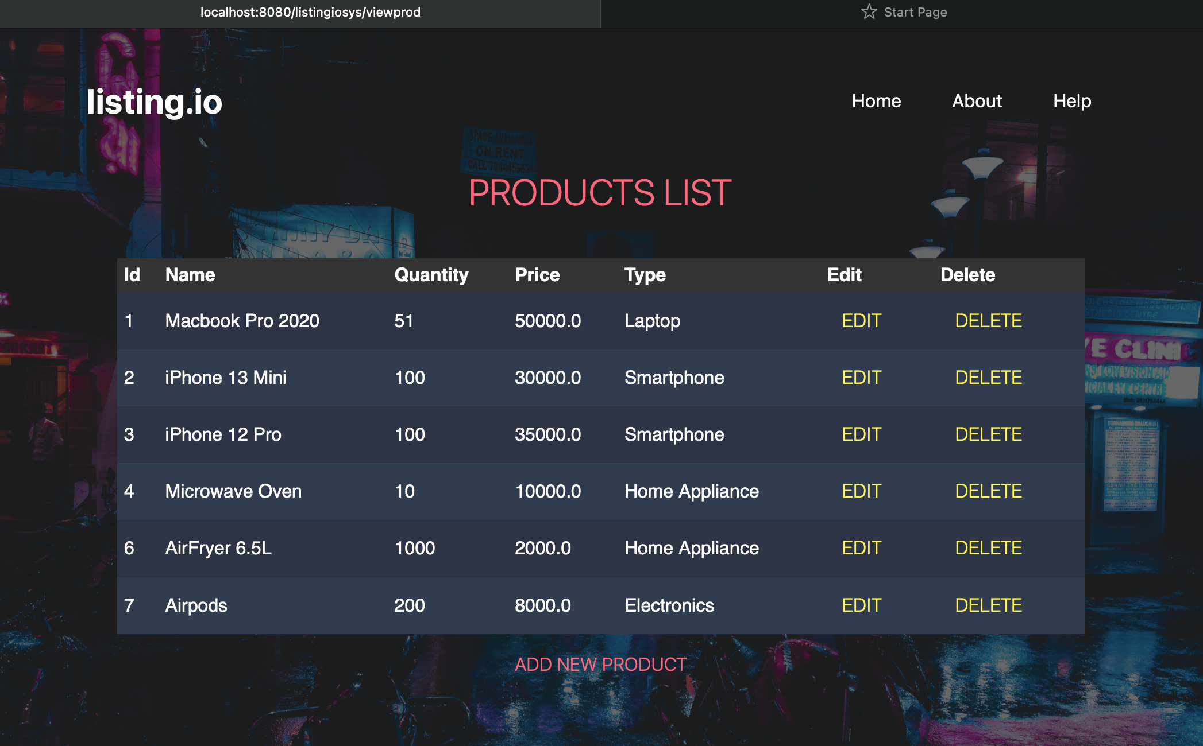

The View Products button redirects you to the products list wherein you can see the products that are currently in the inventory and database. There are also corresponding EDIT and DELETE functions as well as Add new product button.

## EDIT BUTTON

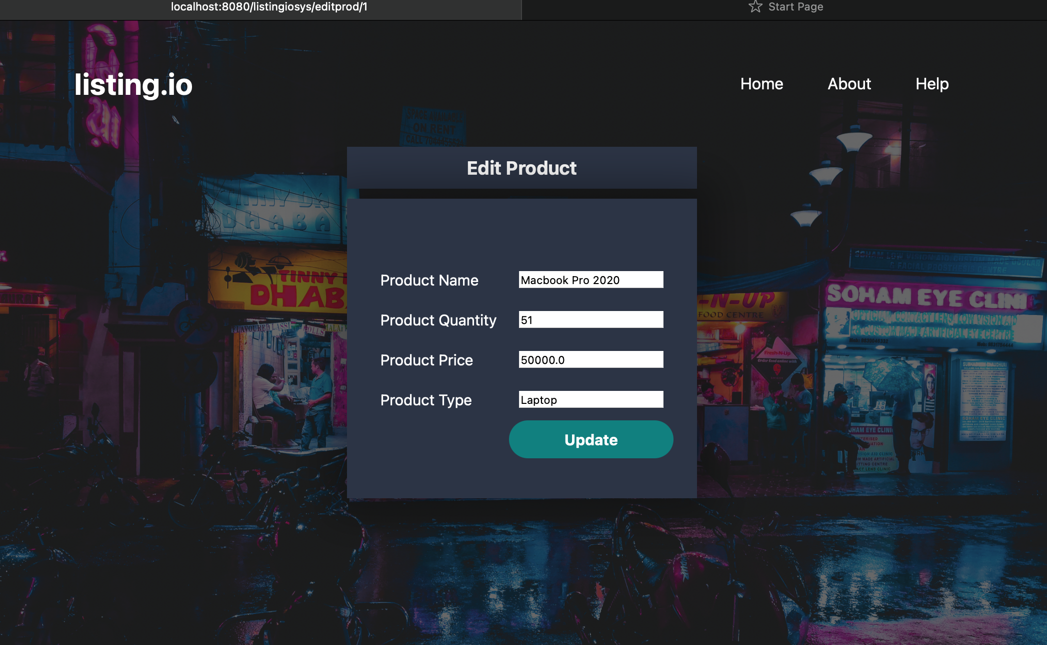

The EDIT button redirects you to the edit form wherein you can maintain the product name, quantity, price and type field. The submission can be made by clicking the Update button.

## DELETE BUTTON



The DELETE button will delete the certain record that you decided to remove from the database.

# Developer’s Notes

Please feel free to contact and connect with me through my linked-in account below. Thank you!

<https://www.linkedin.com/in/reymar-dela-paz-0a26a0196/>